**Create a Spring Web Project using Maven**

SpringLearnApplication.java

package com.cognizant;

import org.springframework.boot.SpringApplication;

import org.springframework.boot.autoconfigure.SpringBootApplication;

@SpringBootApplication

public class SpringLearnApplication {

public static void main(String[] args) {

System.out.println("Starting SpringLearnApplication...");

SpringApplication.run(SpringLearnApplication.class, args);

System.out.println("SpringLearnApplication started.");

}

}

Pom.xml

<dependencies>

<dependency>

<groupId>org.springframework.boot</groupId>

<artifactId>spring-boot-starter-web</artifactId>

</dependency>

<dependency>

<groupId>org.springframework.boot</groupId>

<artifactId>spring-boot-devtools</artifactId>

<scope>runtime</scope>

<optional>true</optional>

</dependency>

<dependency>

<groupId>org.springframework.boot</groupId>

<artifactId>spring-boot-starter-test</artifactId>

<scope>test</scope>

</dependency>

</dependencies>

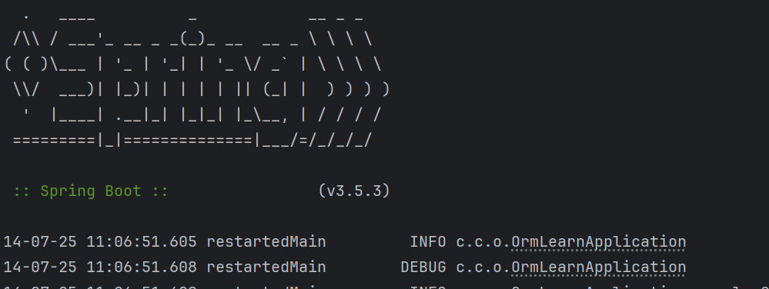

**Spring Core – Load Country from Spring Configuration XML**

**country.xml**

<?xml version="1.0" encoding="UTF-8"?>

<beans xmlns="http://www.springframework.org/schema/beans"

xmlns:xsi="http://www.w3.org/2001/XMLSchema-instance"

xsi:schemaLocation="http://www.springframework.org/schema/beans

http://www.springframework.org/schema/beans/spring-beans.xsd">

<bean id="country" class="com.cognizant.springlearn.Country">

<property name="code" value="IN" />

<property name="name" value="India" />

</bean></beans>

**Country.java**

package com.cognizant.springlearn;

import org.slf4j.Logger;

import org.slf4j.LoggerFactory;

public class Country {

private String code;

private String name;

private static final Logger LOGGER = LoggerFactory.getLogger(Country.class);

public Country() {

LOGGER.debug("Inside Country Constructor.");

}

public String getCode() {

LOGGER.debug("Getting country code: {}", code);

return code;

}

public void setCode(String code) {

LOGGER.debug("Setting country code to: {}", code);

this.code = code;

}

public String getName() {

LOGGER.debug("Getting country name: {}", name);

return name;

}

public void setName(String name) {

LOGGER.debug("Setting country name to: {}", name);

this.name = name;

}

@Override

public String toString() {

return "Country [code=" + code + ", name=" + name + "]";

}

}

**SpringLearnApplication.java**

package com.cognizant.springlearn;

import org.slf4j.Logger;

import org.slf4j.LoggerFactory;

import org.springframework.context.ApplicationContext;

import org.springframework.context.support.ClassPathXmlApplicationContext;

public class SpringLearnApplication {

private static final Logger LOGGER = LoggerFactory.getLogger(SpringLearnApplication.class);

public static void main(String[] args) {

LOGGER.debug("STARTING MAIN METHOD...");

displayCountry();

LOGGER.debug("ENDING MAIN METHOD...");

}

public static void displayCountry() {

ApplicationContext context = new ClassPathXmlApplicationContext("country.xml");

Country country = context.getBean("country", Country.class);

LOGGER.debug("Country : {}", country.toString());

}

}

**log4j.xml**

<?xml version="1.0" encoding="UTF-8"?>

<configuration>

<appender name="STDOUT" class="ch.qos.logback.core.ConsoleAppender">

<encoder>

<pattern>%d{yyyy-MM-dd HH:mm:ss} %-5level %logger{36} - %msg%n</pattern>

</encoder>

</appender>

<root level="debug">

<appender-ref ref="STDOUT" />

</root>

</configuration>



**Hello World RESTful Web Service**

package com.cognizant.springlearn.controller;

import org.slf4j.Logger;

import org.slf4j.LoggerFactory;

import org.springframework.web.bind.annotation.GetMapping;

import org.springframework.web.bind.annotation.RestController;

@RestController

public class HelloController {

private static final Logger LOGGER = LoggerFactory.getLogger(HelloController.class);

@GetMapping("/hello")

public String sayHello() {

LOGGER.debug("Start of sayHello()");

String message = "Hello World!!";

LOGGER.debug("End of sayHello()");

return message;

}

}



**REST - Country Web Service**

country.xml

<beans xmlns="http://www.springframework.org/schema/beans"

xmlns:xsi="http://www.w3.org/2001/XMLSchema-instance"

xsi:schemaLocation="http://www.springframework.org/schema/beans

http://www.springframework.org/schema/beans/spring-beans.xsd">

<bean id="country" class="com.cognizant.springlearn.Country">

<property name="code" value="IN" />

<property name="name" value="India" />

</bean>

</beans>

CountryController.java

package com.cognizant.springlearn.controller;

import com.cognizant.springlearn.Country;

import org.slf4j.Logger;

import org.slf4j.LoggerFactory;

import org.springframework.context.ApplicationContext;

import org.springframework.context.support.ClassPathXmlApplicationContext;

import org.springframework.web.bind.annotation.RequestMapping;

import org.springframework.web.bind.annotation.RestController;

@RestController

public class CountryController {

private static final Logger LOGGER = LoggerFactory.getLogger(CountryController.class);

@RequestMapping("/country")

public Country getCountryIndia() {

LOGGER.debug("Start getCountryIndia()");

ApplicationContext context = new ClassPathXmlApplicationContext("country.xml");

Country country = context.getBean("country", Country.class);

LOGGER.debug("End getCountryIndia()");

return country;

}

}

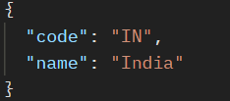

pom.xml

<dependencies>

<dependency>

<groupId>org.springframework.boot</groupId>

<artifactId>spring-boot-starter-web</artifactId>

</dependency>

<dependency>

<groupId>org.springframework.boot</groupId>

<artifactId>spring-boot-starter-security</artifactId>

</dependency>

<dependency>

<groupId>io.jsonwebtoken</groupId>

<artifactId>jjwt</artifactId>

<version>0.9.1</version>

</dependency>

</dependencies>

JwtUtil.java

package com.cognizant.springlearn.util;

import io.jsonwebtoken.Jwts;

import io.jsonwebtoken.SignatureAlgorithm;

import org.springframework.stereotype.Component;

import java.util.Date;

@Component

public class JwtUtil {

private static final String SECRET_KEY = "secret";

public String generateToken(String username) {

long currentTime = System.currentTimeMillis();

return Jwts.builder()

.setSubject(username)

.setIssuedAt(new Date(currentTime))

.setExpiration(new Date(currentTime + 1000 * 60 * 60)) // 1 hour validity

.signWith(SignatureAlgorithm.HS256, SECRET_KEY)

.compact();

}

}

AuthenticationController.java

package com.cognizant.springlearn.controller;

import com.cognizant.springlearn.util.JwtUtil;

import jakarta.servlet.http.HttpServletRequest;

import org.apache.tomcat.util.codec.binary.Base64;

import org.slf4j.Logger;

import org.slf4j.LoggerFactory;

import org.springframework.http.ResponseEntity;

import org.springframework.web.bind.annotation.*;

import java.nio.charset.StandardCharsets;

@RestController

public class AuthenticationController {

private static final Logger LOGGER = LoggerFactory.getLogger(AuthenticationController.class);

private final JwtUtil jwtUtil;

public AuthenticationController(JwtUtil jwtUtil) {

this.jwtUtil = jwtUtil;

}

@RequestMapping(value = "/authenticate", method = RequestMethod.GET)

public ResponseEntity<?> authenticate(HttpServletRequest request) {

LOGGER.debug("Start authenticate()");

String authHeader = request.getHeader("Authorization");

if (authHeader == null || !authHeader.startsWith("Basic ")) {

return ResponseEntity.status(401).body("Missing or invalid Authorization header");

}

String base64Credentials = authHeader.substring("Basic ".length());

byte[] credDecoded = Base64.decodeBase64(base64Credentials);

String credentials = new String(credDecoded, StandardCharsets.UTF_8);

final String[] values = credentials.split(":", 2);

String username = values[0];

String password = values[1];

if (!"user".equals(username) || !"pwd".equals(password)) {

return ResponseEntity.status(401).body("Invalid credentials");

}

String token = jwtUtil.generateToken(username);

LOGGER.debug("End authenticate()");

return ResponseEntity.ok().body("{\"token\":\"" + token + "\"}");

}

}

SecurityConfig.java

package com.cognizant.springlearn.config;

import org.springframework.context.annotation.Bean;

import org.springframework.context.annotation.Configuration;

import org.springframework.security.config.annotation.web.builders.HttpSecurity;

import org.springframework.security.web.SecurityFilterChain;

@Configuration

public class SecurityConfig {

@Bean

public SecurityFilterChain filterChain(HttpSecurity http) throws Exception {

http.csrf().disable()

.authorizeHttpRequests()

.requestMatchers("/authenticate").permitAll()

.anyRequest().authenticated();

return http.build();

}

}

